WHY be left in

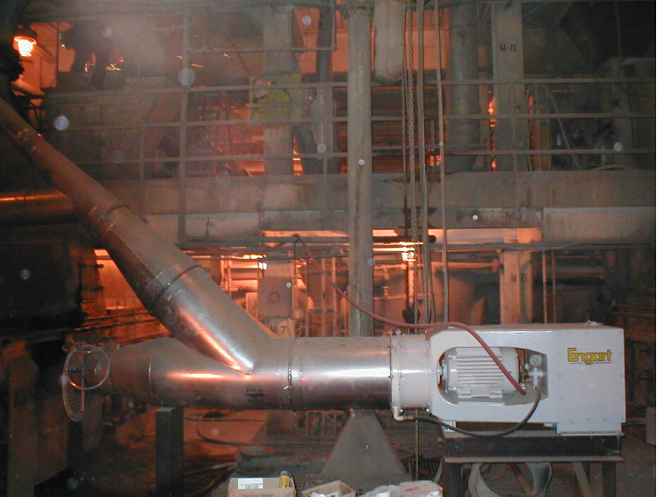

the dust?

ENGART dust extraction
systems are trouble free
compact, reliable dust management units designed to remove 98% of total dust from plant or mining operations. The systems are continually improved at Engart’s ISO 9001 facilities to insure an optimum product to improve the environmental operating
conditions of our customers.

A dust management system you can live with!

>Picture shows a Type 18 installed in a Power Plant FGD building scrubbing fly ash and hydrated lime<

CHOOSE ENGART DUST EXTRACTOR SYSTEMS, AND ELIMINATE BAGHOUSE PROBLEMS!

- No need for compressed air
- Exhaust Inside
- Eliminates return screw conveyors
- No Belts to Maintain
- No Bags to Change
- “Eliminates” Bag-House Explosions

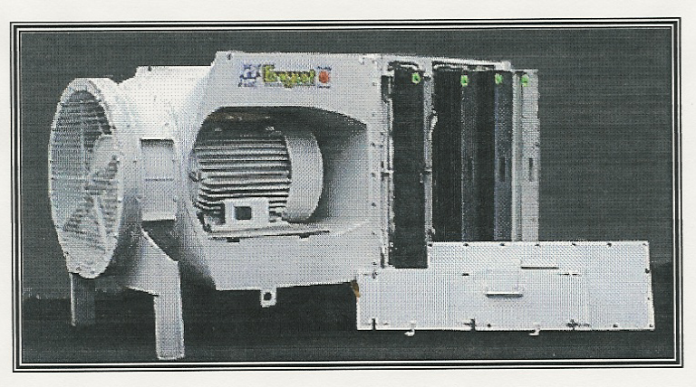
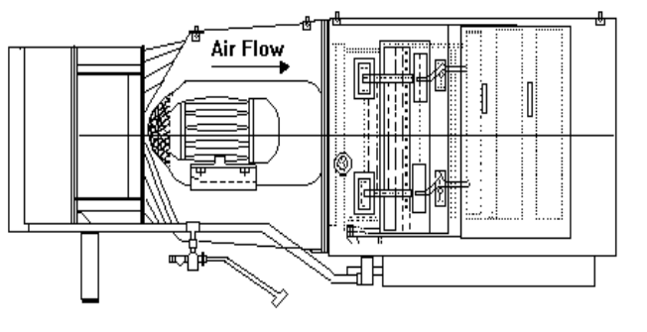
- Bifurcated design – enhances safety
- Consistent air volume
- Multiple size ranges
- Complete system design and turnkey projects
- Easy waste discharge
- Flexible Engineering Approach
- Engineering Support Team

SIZE RANGES:

Type 18 6,000 cfm
Type 24 13,000 cfm
Type 27 17,000 cfm
Type 30 22,500 cfm
Type 36 36,000 cfm

Call Engart for a dust extraction system using our innovative wet scrubber! The Engart team stands ready to design a trouble free, safe, effective dust management system to fit your needs and your budget.

Tel 304.253.0777
Fax 304.253-0719
sales@engartamerica.com
150 Stanaford Rd.

Beckley, WV 25801


- Low Capital Installation and Operating Cost
EN
G
A
R
T

Proven Worldwide

